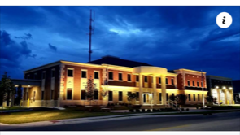
City of Berea
212 Chestnut St.
Berea, KY. 40403

Bruce Fraley Shawn Sandlin Donna Angel
Mayor City Administrator Business Development Director
bfraley@bereaky.gov ssandlin@bereaky.gov dangel@bereaky.gov
859.302.3365 859.661.2874 859.302.1113

Population 16,436
8% Growth Increase from 2020
Day Population 39,640
Median Home Cost $245,532
Median HH Income $59,495
Median Age 39.1
Median Gross Rent $835
Persons per Households 2.60
Berea College #1 College in the Nation
Berea College Tuition Free
Berea College #1Pinnacles Hiking Trails
Berea Art & Crafts Capitol of Kentucky
38 Working Artist
35 Air BnB’s
50 Restaurants
10 Hotels/Motels
3500 Industry Employees
2800 Educational Employees
Saint Joseph Berea Hospital– Common Spirit

